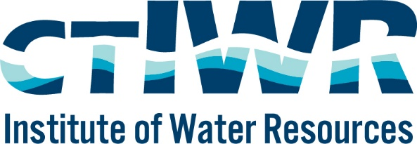

Dear Water Resources Colleague,

The Connecticut Institute of Water Resources (CT IWR) invites the faculty of all Connecticut colleges and universities to submit pre-proposals for freshwater research or education/information transfer programs related to problems of importance in Connecticut and the Northeast Region. Additional information can be found at https://ctiwr.uconn.edu/104b

PLEASE NOTE: Final CT IWR awards are contingent upon Congressional approval of FY 2023 funding for the National Water Resources Research Institutes program.

For FY23, the Connecticut Institute of Water Resources highly encourages proposals from principal investigators who are from underrepresented or underserved groups in STEM, and from institutions that serve majority minority populations (e.g., Historically Black Colleges and Universities, Minority Serving Institutions, Tribal Colleges and Universities, Hispanic Serving Institutions, and community colleges). Additionally, proposals are encouraged that increase diversity, equity, inclusion, and justice, which intersect with water research and resources. Proposals that address issues in historically marginalized or underserved communities are highly encouraged.

NOTE: USGS has requested that all projects have a start date of 9/1/2023

Just Like Last Year: a streamlined pre-proposal process will be used. Please email a 1-2 page pre-proposal to Michael Dietz (Michael.dietz@uconn.edu) and Bo Tao (bo.tao@uconn.edu) with the subject line “FY23 CTIWR 104b proposal”. Please include the following information:
- Project title
- PI name(s) and institution(s)
- Requested funding amount
- Brief abstract of the project, including the problem that the project addresses, how you propose to do the work, and the potential benefits.
- Contact information for 2-3 potential reviewers

Pre-Proposals are due by 4:00 PM, Friday December 9, 2022.

Although we are not requesting a full budget for the pre-proposal, keep in mind that all dollars awarded from this grant must be matched with non-federal funds. **New this year: the nonfederal match required has been reduced from 2:1 to 1:1**

Please share this RFP announcement with other appropriate colleagues that may not be included on our distribution list. If you have questions, please let us know. Thank you for your interest in water resources in Connecticut. Also, I have attached our most recent newsletter, if you are interested.

Michael Dietz, Director
CT Institute of Water Resources
860-486-2436

Bo Tao, Associate Director
860-486-4610

